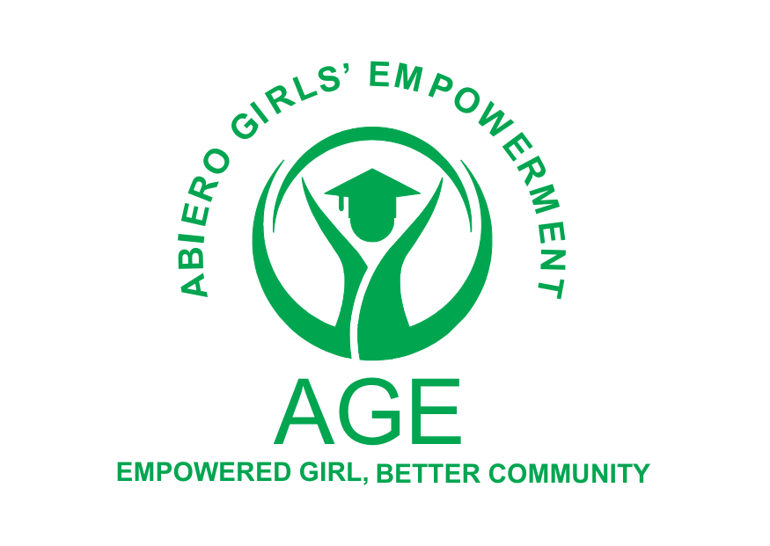

Comprehensive Report on the Mfangano Island DCC's Leaders Meeting

Report on visit to DCC Sena office Suba Central Sub-County - November 28th, 2023

INTRODUCTION AND BACKGROUND:
Abiero Girls’ Empowerment (AGE) is a hands-on charity that actively champions marginalized girls at Wasamo Girls Secondary School (the only girls school located on the remote island of Mfangano and its environs, in Kenya), through financial support and mentorship, allowing them to break generational poverty and become exceptional contributors to society. A lot of these girls, whose community prioritizes marriage and children, have sacrificed their education and ambitions to become child brides and adolescent mothers (often against their will).

The Deputy County Commissioner (DCC) for Suba Central Sub-County, Mr. Samson Akach (Head of State Commendation - HSC), issued a formal invitation to Abiero Girls' Empowerment (AGE) for a leaders' meeting at the Sena DCC's office situated on Mfangano Island. The meeting on November 28th, 2023, aimed to address the pressing issue of rising adolescent pregnancies within the region. Ezekiel Weya, the organization's treasurer, represented AGE at this significant gathering. This report encapsulates the crucial discussions, proposals, and recommendations that transpired during this collaborative effort to tackle the challenging circumstances faced by the adolescent population in Mfangano Island.

METHODOLOGY:
A meeting convened at the DCC Sena office in Suba Central Sub-County on November 28th, 2023, at 9 am to address the escalating issue of adolescent pregnancies in Mfangano Island. During the session, Mr. Akach shared disturbing statistics, reporting 282 cases of teenage pregnancies on Mfangano Island from January 2022 to September 2023. The implications of these factors on girl-child education were discussed, with potential school closures due to low enrollment and the prevalence of adolescent pregnancies.

PROPOSED PARTNERSHIP WITH AGE:
It was suggested that AGE collaborates with the Office of the Deputy County Commissioner and partners with the Ministry of Education and Health for Suba Central Sub-County. AGE is expected to conduct a detailed demographic and baseline survey on Mfangano Island to gather essential data for effective planning and decision-making.

STRATEGIES AND INTERVENTION
The strategies and interventions discussed for the prevention and reduction of adolescent pregnancies include:

Operation Back to School Committee: A comprehensive proposal was presented for Operation Back to School (OBS), an aggressive campaign requiring collaboration among diverse stakeholders, including the Government, private sector, Non-governmental organizations (NGOs), community leaders, and other stakeholders. Establishment of a committee with the core mandate of returning all adolescents under the age of 19 back to school and ensuring their sustained education until completion.

Educator Empowerment: Providing comprehensive training to heads of schools and teachers to enhance their knowledge and understanding of biological and sex education. This includes reproductive health awareness to make students aware of the risks and consequences of adolescent pregnancies on their physical and mental health.

Influencing Factors Assessment: Developing a comprehensive list of influencing factors such as peer pressure and social media and advocating for a review of policies and legislation to mitigate the effects contributing to the increasing number of adolescent pregnancies, school dropouts, and sexually transmitted infections (STIs).

Beach Management Unit (BMU) Regulations Review: Review BMU regulations for the Mfangano Islands to ensure that only individuals over the age of 19, vetted by the BMU vetting committee, can become authorized fishermen. This includes mandatory requirements for vetting, such as an introduction letter, a valid certificate of good conduct, and an original National Identity Card.

Adolescent Digital Outreach (ADO) App: Proposing the development of a mobile app targeting adolescents aged 14 to 19, called Adolescent Digital Outreach (ADO). The app would provide a platform for sharing experiences and seeking various educational, health, social, and other services, with parental consent required for registration.

Regulation of Holiday Tournaments: Advocating for the regulation of holiday tournaments, with teachers taking full responsibility for their students during such events.

Policy and Legislation Review: Conducting a review of policies and legislation to identify gaps contributing to the vulnerability of adolescents at the family, school, and community levels. Emphasizing the need for enhanced transparency and accountability to ensure the protection of human rights, education, health, and basic needs of adolescents.

Community-Based Informers: Highlighting the importance of community-based informers who report directly to the Deputy County Commissioner (DCC). Their role is to ensure that parents, teachers, community leaders, spiritual leaders, security agencies, and village elders fulfill their responsibilities within the community to protect adolescents from abuse, cultural practices, social stigma, and various risks.

Resource Mobilization: Emphasizing the crucial need for resource mobilization and fundraising to sustain the Operation Back to School (OBS) campaign. This includes funding for school fees, activities, and supporting basic needs such as housing, food, clothing, education, healthcare, and dignity packs.

Rotational Educational Trips: Recommending a rotational program for educational trips, ensuring that every school within Mfangano Island has at least one educational trip per year outside the Island for exposure purposes.

RECOMMENDATIONS
- Strengthen collaboration between AGE, the Deputy County Commissioner's office, and relevant ministries for a more unified approach.
- Allocate resources for the timely execution of the proposed demographic and baseline survey on Mfangano Island.
- Initiate immediate training programs for educators on comprehensive biological and sex education.
- Encourage community participation in the OBS campaign through awareness programs and incentives.
- Establish clear guidelines for the Adolescent Digital Outreach (ADO) app, ensuring its effectiveness and safety for adolescent users.

CONCLUSION
This report encapsulates the key discussions and proposed actions to address the critical issue of adolescent pregnancies in Mfangano Island. Emphasizing the need for collaborative efforts and comprehensive strategies, the recommendations aim to guide future initiatives for a more impactful outcome.

Report on Visit to Soklo Health Centre - November 28th, 2023
INTRODUCTION
On November 28th, 2023, a visit was organized to Soklo Health Centre for a meeting with Community Health Assistant Mr. Philip Kwach Bibinga at noon. This marked a pivotal opportunity for a comprehensive discussion on community health strategies and potential sustainable energy projects for the Soklo and Gulwe areas. The meeting aimed to gather insights into the current state of community health, with a specific focus on the roles of Community Health Promoters (CHPs) and the challenges posed by adolescent pregnancies. Furthermore, the agenda included an assessment of the areas' potential for solar mini-grid, wind power, and water projects.

METHODOLOGY
The meeting commenced at noon with a detailed introduction to Mr. Philip Kwach Bibinga, the Community Health Assistant for Soklo North and Soklo South Sub-locations. This initial session set the tone for insightful discussions on the structure of the community health team, comprising 8 CHPs, 10 Community Health Committee Members, and 11 Village Elders. These community stakeholders actively engage in data collection and provide first aid as part of the Government's community health strategy.
A comprehensive overview of the role of CHPs was presented, emphasizing their critical functions such as mapping pregnant women and girls, conducting malaria tests, delivering health and sex education, and advocating for family planning at the household level. Challenges related to adolescent pregnancies were identified, including the vicious cycle of poverty, cultural norms, lack of coordination and support systems, and the discontinuation of community healthcare interventions like the Family Support Community-Based Initiative (FASCOBI).
The second part of the report delved into the agenda for evaluating the potential for a solar mini-grid, wind power, and water projects in Soklo and Gulwe areas.

RECOMMENDATIONS
Community Health Strategies Recommendations:
- Strengthening CHPs:
  - Facilitate continuous training programs for CHPs to enhance their skills and knowledge.
  - Provide necessary resources, including health test kits, to empower CHPs in their roles.
- Collaboration and Coordination:
  - Strengthen collaboration between the community health team, government health facilities, and other stakeholders.
  - Establish effective coordination mechanisms to address the challenges posed by adolescent pregnancies.

Energy Projects Recommendations:
- Feasibility Studies:
  - Undertake detailed feasibility studies for both solar mini-grid and wind power projects, considering geographical factors, design requirements, and financial viability.
  - Engage the community in the decision-making process to ensure project alignment with their needs and concerns.
- Renewable Energy Transition:
  - Explore options for transitioning from the existing diesel power generator to renewable energy sources to reduce environmental impact and maintenance costs.
  - Promote community awareness of the benefits of renewable energy and encourage their active participation in the transition process.
Water Project Recommendations:
- Feasibility Study for Water Project:
  - Conduct a comprehensive feasibility study for a water project, analyzing water treatment and distribution systems, infrastructure requirements, environmental impacts, and community engagement.
- Community Engagement:
  - Engage the community in discussions about the proposed water project, addressing their water needs, concerns, and expectations.
  - Establish sustainable water management practices and promote community ownership of the water project.
CONCLUSION
The visit to Soklo Health Centre proved to be a valuable opportunity to gain insights into community health strategies and challenges related to adolescent pregnancies. The exploration of potential sustainable energy projects for the Soklo and Gulwe areas highlighted significant opportunities for future development. The recommendations underscore the importance of collaboration, feasibility studies, and community engagement in addressing health and energy-related challenges, contributing to the overall well-being and sustainability of the region.

Report on Suba Central Sub-County Leaders Meeting - November 29th, 2023
INTRODUCTION
A significant leaders' meeting took place on November 29th, 2023, at Sena Sub-County Hospital grounds. The event brought together esteemed leaders from various sectors, including government officials, education, health, fisheries, agriculture, and community representatives. The meeting aimed to address critical issues affecting Mfangano Island, focusing on education, healthcare, fisheries, agriculture, land adjudication, energy, and community development.

ATTENDEES
The meeting saw the participation of key figures, including:
- District County Commissioner: Mr. Samson Akach
- Assistant County Commissioner: Mr. Philip Kazungu
- Head of Ministry departments
- Director of Education Suba Central Sub-County: Mr. Chacha Paul Werema
- Medical Health Officer Sena Sub-County Hospital: Dr. Joshua Odhiambo
- Fisheries Sub-County Officer: Mr. Alex Opiyo
- Lands Sub-County Land Adjudication Officer: Mr. Ogutu
- Agriculture Sub-County Agricultural Officer: Mr. Benson Muga
- Coast Guard – Austin
- All Head Teachers within Mfangano Island
- All Chiefs and Assistant Chiefs within Mfangano Island
- All Chairmen of the Beach Management Unit within Mfangano Island
- Chairman of Mfangano Development Forum
- Kenya Power Representative: Mr. Patrick Ojwamg
- Partners of NGOs, CBOs, Water bus services, and Ferry Services
- Business community within Mfangano Island
- Spiritual and Religious leaders within Mfangano Island
Director of Education's Report - Mr. Chacha Paul Warema:
For Kenya Certificate of Primary Education (KCPE) results in 2023:
- 423 girls and 404 boys sat for the exams, totaling 827 candidates.
- The highest-scoring student was a boy from Ramba with 411 marks.
- Gethsemane Garden Christian Centre (GGCC) emerged as the best-performing school with a mean grade of 350 marks.
For Standard 6, Kenya Primary School Education Assessment (KPSEA):
- 352 boys and 346 girls enrolled, with a total of 698 students.

For Kenya Certificate of Secondary Education (KCSE):
- 139 boys and 150 girls enrolled, awaiting results.
- Concerns were raised about 282 reported teenage pregnancy cases and low student enrolment, which could lead to school closures.
Medical Health Officer's Report - Dr. Joshua Odhiambo:
- 9 government health facilities and 6 private health facilities serve Mfangano Island.
- Recorded 282 teenage pregnancy cases from January 2022 to September 2023.
- Highlighted rising cases of Gender-Based Violence (GBV) and child defilement.
- Urged for comprehensive support systems, awareness against GBV, and safe reporting mechanisms.

Fisheries Sub-County Officer's Report - Mr. Alex Opiyo:
- Advocated for fish cage farming due to decreasing fish in Lake Victoria.
- Called for BMU restructuring and the need for a new fisheries office Lands Sub County Land Adjudication Officer's Report - Mr. Ogutu:
- in Sena Sub-County.
- Urged action against illegal fishermen and protection of vulnerable girls.
Kenya Power Representative's Report - Mr. Patrick Ojwamg:
- Mfangano Island is powered by a costly diesel generator.
- Urged exploration of renewable energy sources (solar, wind) for a reliable power supply.
- Emphasized the need for expanded power connectivity and transformer maximization.
- Land adjudication ongoing since 1997, nearing completion.
- Some land disputes need resolution before issuing land ownership titles.
Sub County Agricultural Officer's Report - Mr. Benson Muga:
- Encouraged youth groups to engage in farming for poverty alleviation and food security.
- Highlighted issues of roaming animals damaging crops and the infestation of monkeys.
Deputy County Commissioner's Statements:
- Emphasized the importance of education, calling for increased enrolment and infrastructure improvement.
- Announced the budget for the construction of the Sub-County Headquarters in Sena.
- Urged submission of BMU constitutions for review.
- Called for Operation Back to School (OBS) to address the increasing rate of adolescent pregnancies and school dropouts.
- Expressed concern about the potential closure of schools due to low enrolment.
- Urged community attendance at baraza’s and highlighted the need for open discussions on various issues.
CONCLUSION
The leaders' meeting provided a comprehensive overview of critical issues affecting Mfangano Island. From education challenges to healthcare, fisheries, agriculture, and energy concerns, the reports shed light on the complex dynamics that need urgent attention. The call for collaboration, community involvement, and strategic interventions will be crucial in addressing these issues and ensuring the sustainable development of Mfangano Island.

